2020 Operating System Project 1 - Process Scheduling
by R07922148 鄭嘉賡

Design
使用兩顆CPU, CPU 0用作排程, CPU 1用來跑子程式.

main
- 讀取input data,將每個process按照ready time 排列
- 建立child processes,並為其分配CPU和設定priority
- 當有process在跑的時候,check是否已經完成
- 檢查是否有process已經ready準備要運行
- 將CPU交給下一個要運行的Process,如果換人就要content switch
- process運行完一個Unit time 之後process剩下的時間減去Unit time
- 重複步驟直到跑完所有Processes

Process
- 讀取input data,將每個process按照ready time 排列
- 建立child processes,並為其分配CPU和設定priority

Queue
- 為Round-Robin規則下,run完的process如果還要運行就要重新排隊,每一個重新排隊的都需要排在Queue最後.

Scheduling
- 按照四種不同的scheduling policy進行排程,從而得知下一個要運行的child process

System Calls
兩個自己的syscalls，需要放入linux/kernel資料夾與kernel一同編譯。
- 334 my_gettime
- 335 my_dprint
用getnstimeofday來讀取當前時間戳 asmlinkage long sys_my_gettime(void) { static const long giga = 1000000000; struct timespec _t; getnstimeofday(&_t); return (_t.tv_sec*giga + _t.tv_nsec); }
用來printkl來print dmesg asmlinkage void sys_my_dprint(int pid,long start_time, long end_time) { static const long giga = 1000000000; printk("[Project1] %d %ld.%09ld %ld.%09ld\n", pid, start_time / giga, start_time % giga, end_time / giga, end_time % giga); return; }

Experiment and Results

Environment Platform OS Kernel Virtualbox 6.1 on win10 Ubuntu 16.04 Linux 4.14.25

First In First Out （FIFO）

Test Data 1
FIFO 5 P1 0 500 P2 0 500 P3 0 500 P4 0 500 P5 0 500

Exclusion Result
[ 3999.001639] [Project1] 2647 1588168462.496226788 1588168463.313589004 [ 3999.839055] [Project1] 2648 1588168463.313712051 1588168464.150971127 [ 4000.675117] [Project1] 2649 1588168464.151094442 1588168464.986999186 [ 4001.525969] [Project1] 2650 1588168464.987171502 1588168465.837815910 [ 4002.342739] [Project1] 2651 1588168465.838098292 1588168466.654552204

Comparison of Theoretical and Pretical Results
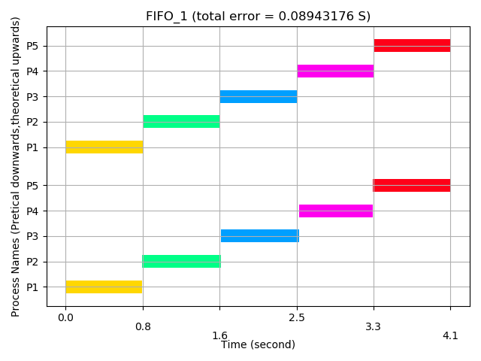

Test Data 2
FIFO 4 P1 0 80000 P2 100 5000 P3 200 1000 P4 300 1000

Exclusion Result
[ 4137.248056] [Project1] 2659 1588168466.665424981 1588168601.554405701 [ 4145.349248] [Project1] 2660 1588168601.554547696 1588168609.655599126 [ 4146.967657] [Project1] 2661 1588168609.655724017 1588168611.274006429 [ 4148.611852] [Project1] 2662 1588168611.274133536 1588168612.918200852

Comparison of Theoretical and Pretical Results
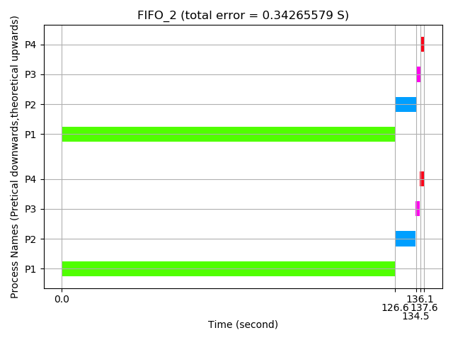

Test Data 3
FIFO 7 P1 0 8000 P2 200 5000 P3 300 3000 P4 400 1000 P5 500 1000 P6 500 1000 P7 600 4000

Exclusion Result
[ 4162.329934] [Project1] 2676 1588168612.929549667 1588168626.636273411 [ 4170.374733] [Project1] 2677 1588168626.636408431 1588168634.681060230 [ 4175.380045] [Project1] 2678 1588168634.681185265 1588168639.686362470 [ 4177.032926] [Project1] 2679 1588168639.686498069 1588168641.339239132 [ 4178.705258] [Project1] 2680 1588168641.339363096 1588168643.011568446 [ 4180.369589] [Project1] 2681 1588168643.011691793 1588168644.675895937 [ 4187.096760] [Project1] 2682 1588168644.676043260 1588168651.403048890

Comparison of Theoretical and Pretical Results
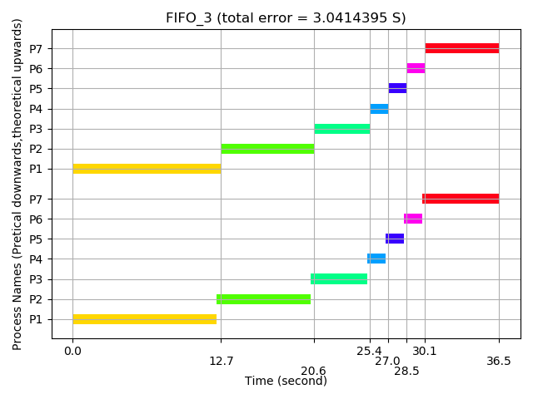

Test Data 4
FIFO 4 P1 0 2000 P2 500 500 P3 500 200 P4 1500 500

Exclusion Result
[ 4190.297946] [Project1] 2690 1588168651.414808157 1588168654.604226191 [ 4191.091461] [Project1] 2691 1588168654.604343397 1588168655.397738641 [ 4191.412277] [Project1] 2692 1588168655.397894474 1588168655.718553744 [ 4192.220176] [Project1] 2693 1588168655.718673694 1588168656.526449525

Comparison of Theoretical and Pretical Results
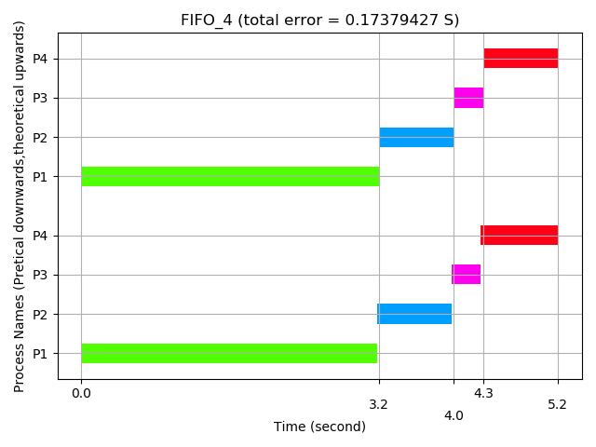

Test Data 5
FIFO 7 P1 0 8000 P2 200 5000 P3 200 3000 P4 400 1000 P5 400 1000 P6 600 1000 P7 600 4000

Exclusion Result
[ 4205.588340] [Project1] 2701 1588168656.538213131 1588168669.894567641 [ 4213.891166] [Project1] 2702 1588168669.894703158 1588168678.197359122 [ 4218.449547] [Project1] 2703 1588168678.197513418 1588168682.755719731 [ 4220.153260] [Project1] 2704 1588168682.755861868 1588168684.459423697 [ 4221.889144] [Project1] 2705 1588168684.459548296 1588168686.195299602 [ 4223.546254] [Project1] 2706 1588168686.195427609 1588168687.852402136 [ 4229.800881] [Project1] 2707 1588168687.852524843 1588168694.106996663

Comparison of Theoretical and Pretical Results
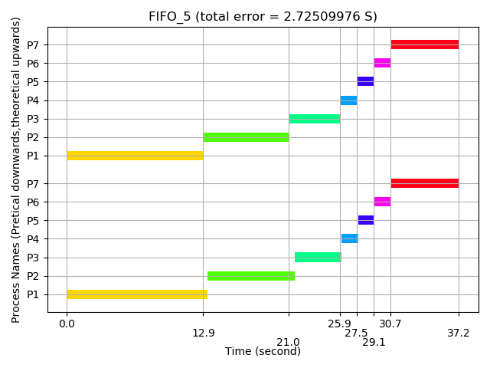

RR (Round-Robin)

Test Data 1
RR 5 P1 0 500 P2 0 500 P3 0 500 P4 0 500 P5 0 500

Exclusion Result
[ 3617.034446] [Project1] 2454 1588168080.535052288 1588168081.361916858 [ 3617.834567] [Project1] 2455 1588168081.362056980 1588168082.162005850 [ 3618.644825] [Project1] 2456 1588168082.162430872 1588168082.972230385 [ 3619.396872] [Project1] 2457 1588168082.972363093 1588168083.724246657 [ 3620.206140] [Project1] 2458 1588168083.724532296 1588168084.533482284

Comparison of Theoretical and Pretical Results
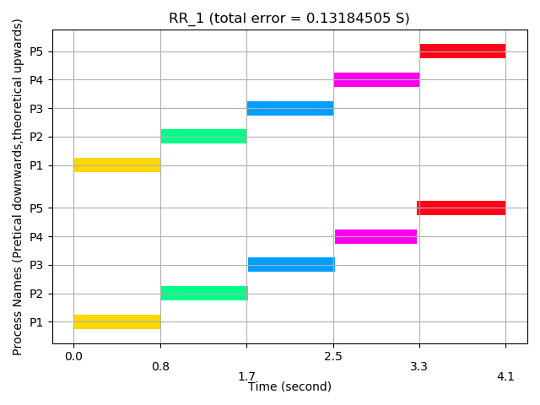

Test Data 2
RR 2 P1 600 4000 P2 800 5000

Exclusion Result
[ 3633.079858] [Project1] 2467 1588168085.417022320 1588168097.406678115 [ 3635.527349] [Project1] 2468 1588168086.158480668 1588168099.854069875

Comparison of Theoretical and Pretical Results
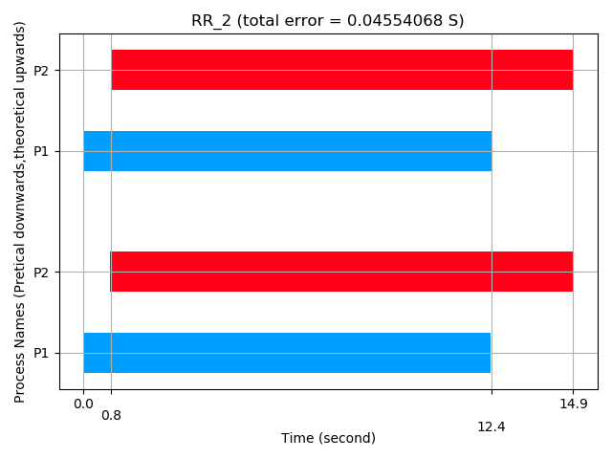

Test Data 3
RR 6 P1 1200 5000 P2 2400 4000 P3 3600 3000 P4 4800 7000 P5 5200 6000 P6 5800 5000

Exclusion Result
[ 3665.174424] [Project1] 2478 1588168106.260601535 1588168129.499940848 [ 3667.705237] [Project1] 2476 1588168101.571097830 1588168132.030650763 [ 3668.504261] [Project1] 2477 1588168104.009259327 1588168132.829643312 [ 3681.991124] [Project1] 2481 1588168112.868398091 1588168146.315958496 [ 3685.355679] [Project1] 2480 1588168110.379141254 1588168149.680375937 [ 3687.021035] [Project1] 2479 1588168109.550226157 1588168151.345665143

Comparison of Theoretical and Pretical Results
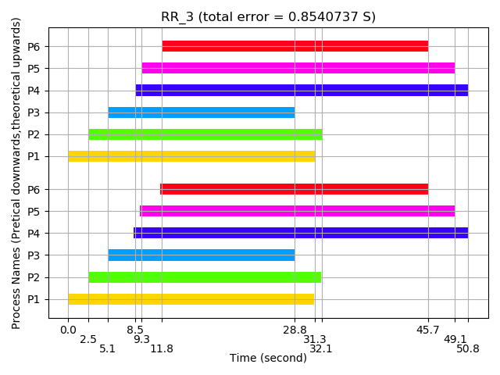

Test Data 4
RR 7 P1 0 8000 P2 200 5000 P3 300 3000 P4 400 1000 P5 500 1000 P6 500 1000 P7 600 4000

Exclusion Result
[ 3696.117990] [Project1] 2494 1588168153.843135725 1588168160.442250363 [ 3696.981309] [Project1] 2495 1588168154.644135471 1588168161.305535358 [ 3697.858220] [Project1] 2496 1588168155.474344742 1588168162.182409687 [ 3711.103706] [Project1] 2493 1588168152.990798487 1588168175.427358179 [ 3717.654807] [Project1] 2497 1588168157.153814645 1588168181.978193134 [ 3720.102524] [Project1] 2492 1588168152.180365431 1588168184.425810889 [ 3725.063099] [Project1] 2491 1588168151.356064047 1588168189.386184088

Comparison of Theoretical and Pretical Results
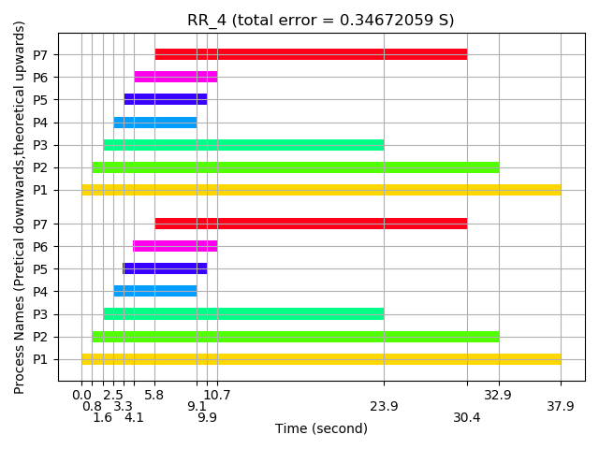

Test Data 5
RR 7 P1 0 8000 P2 200 5000 P3 200 3000 P4 400 1000 P5 400 1000 P6 600 1000 P7 600 4000

Exclusion Result
[ 3733.968150] [Project1] 2510 1588168191.856440697 1588168198.290873352 [ 3734.798315] [Project1] 2511 1588168192.671516466 1588168199.121004969 [ 3736.347727] [Project1] 2512 1588168194.287407109 1588168200.670353572 [ 3748.674285] [Project1] 2509 1588168191.068122937 1588168212.996410915 [ 3755.269664] [Project1] 2513 1588168195.031447116 1588168219.591518906 [ 3757.784351] [Project1] 2508 1588168190.219940103 1588168222.106106857 [ 3762.622342] [Project1] 2507 1588168189.397001909 1588168226.943902059

Comparison of Theoretical and Pretical Results
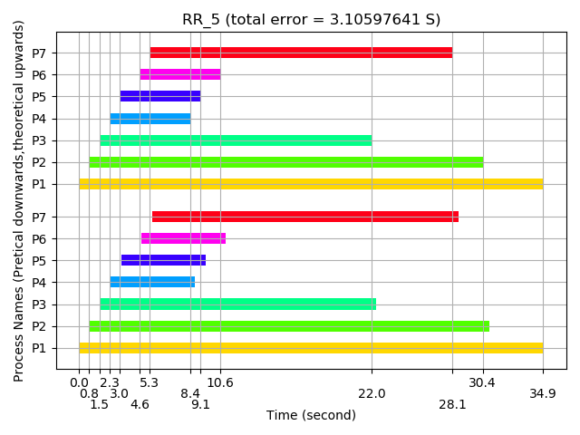

SJF (Shortest Job First)

Test Data 1
SJF 4 P1 0 7000 P2 0 2000 P3 100 1000 P4 200 4000

Exclusion Result
[ 3765.983625] [Project1] 2522 1588168226.954558352 1588168230.305048211 [ 3767.652945] [Project1] 2523 1588168230.305194086 1588168231.974300075 [ 3774.514104] [Project1] 2524 1588168231.974428459 1588168238.835180271 [ 3786.270682] [Project1] 2521 1588168238.835308592 1588168250.591280946

Comparison of Theoretical and Pretical Results
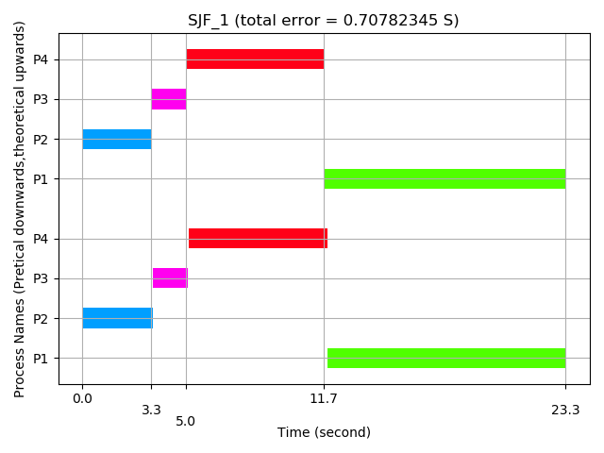

Test Data 2
SJF 5 P1 100 100 P2 100 4000 P3 200 200 P4 200 4000 P5 200 7000

Exclusion Result
[ 3786.561881] [Project1] 2534 1588168250.744927722 1588168250.882468040 [ 3786.845468] [Project1] 2536 1588168250.884163185 1588168251.166043474 [ 3792.494621] [Project1] 2535 1588168251.166166475 1588168256.814967352 [ 3798.297399] [Project1] 2537 1588168256.815149377 1588168262.617509196 [ 3809.386146] [Project1] 2538 1588168262.617713757 1588168273.705805114

Comparison of Theoretical and Pretical Results
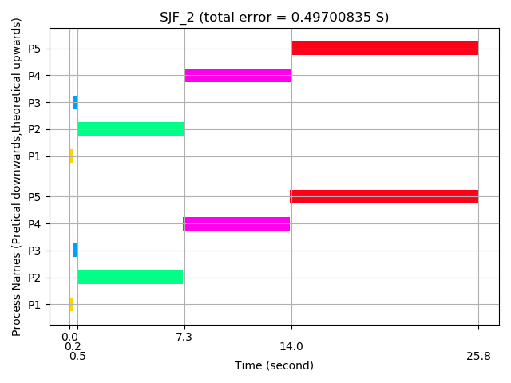

Test Data 3
SJF 8 P1 100 3000 P2 100 5000 P3 100 7000 P4 200 10 P5 200 10 P6 300 4000 P7 400 4000 P8 500 9000

Exclusion Result
[ 3814.503513] [Project1] 2546 1588168273.863863245 1588168278.822964384 [ 3814.520351] [Project1] 2549 1588168278.823126113 1588168278.839801302 [ 3814.535997] [Project1] 2550 1588168278.839986493 1588168278.855448418 [ 3821.031143] [Project1] 2551 1588168278.855562824 1588168285.350329673 [ 3827.749584] [Project1] 2552 1588168285.350816721 1588168292.068497834 [ 3835.887565] [Project1] 2547 1588168292.068630251 1588168300.206147578 [ 3847.365435] [Project1] 2548 1588168300.206290881 1588168311.683551576 [ 3862.149434] [Project1] 2553 1588168311.683682669 1588168326.466949704

Comparison of Theoretical and Pretical Results
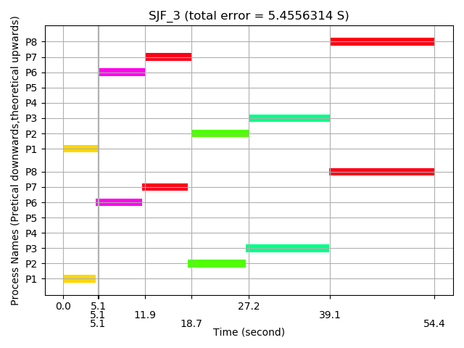

Test Data 4
SJF 5 P1 0 3000 P2 1000 1000 P3 2000 4000 P4 5000 2000 P5 7000 1000

Exclusion Result
[ 3867.236918] [Project1] 2563 1588168326.481374039 1588168331.554226504 [ 3868.807832] [Project1] 2564 1588168331.554368176 1588168333.125076231 [ 3874.867014] [Project1] 2565 1588168333.125712900 1588168339.184011566 [ 3876.406792] [Project1] 2567 1588168339.184429197 1588168340.723727941 [ 3879.764819] [Project1] 2566 1588168340.723941473 1588168344.081617662

Comparison of Theoretical and Pretical Results
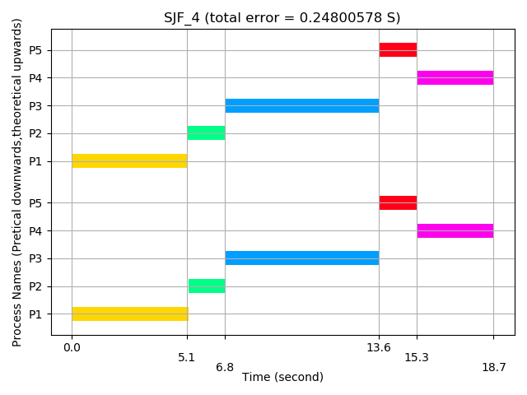

Test Data 5
SJF 4 P1 0 2000 P2 500 500 P3 1000 500 P4 1500 500

Exclusion Result
[ 3882.954626] [Project1] 2575 1588168344.092670505 1588168347.271295043 [ 3883.779132] [Project1] 2576 1588168347.271431682 1588168348.095767885 [ 3884.601899] [Project1] 2577 1588168348.095896804 1588168348.918501367 [ 3885.462978] [Project1] 2578 1588168348.918630081 1588168349.779545250

Comparison of Theoretical and Pretical Results
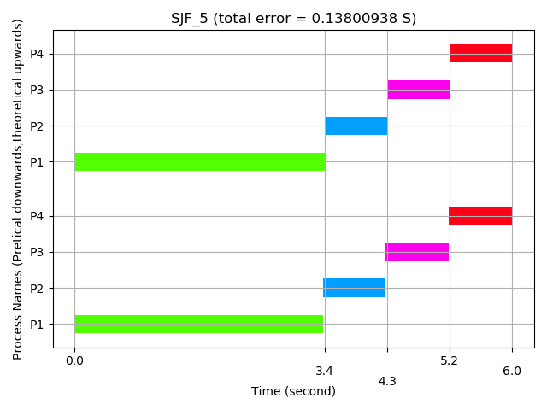

Preemptive Shortest Job First（PSJF）

Test Data 1
PSJF 4 P1 0 10000 P2 1000 7000 P3 2000 5000 P4 3000 3000

Exclusion Result
[ 3895.237368] [Project1] 2589 1588168354.697952554 1588168359.553537881 [ 3901.503196] [Project1] 2588 1588168353.044345510 1588168365.819111444 [ 3911.030351] [Project1] 2587 1588168351.439450196 1588168375.345879032 [ 3925.549427] [Project1] 2586 1588168349.791059823 1588168389.864364762

Comparison of Theoretical and Pretical Results
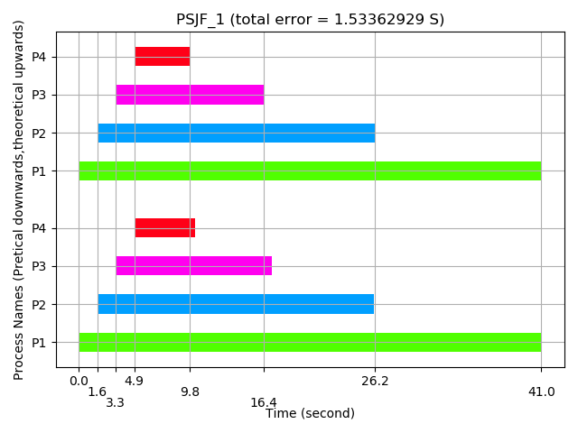

Test Data 2
PSJF 5 P1 0 3000 P2 1000 1000 P3 2000 4000 P4 5000 2000 P5 7000 1000

Exclusion Result
[ 3928.807554] [Project1] 2600 1588168391.507021802 1588168393.122358970 [ 3932.197447] [Project1] 2599 1588168389.874888729 1588168396.512113653 [ 3937.211036] [Project1] 2602 1588168398.196267289 1588168401.525498956 [ 3938.857241] [Project1] 2603 1588168401.526978091 1588168403.171636682 [ 3943.701520] [Project1] 2601 1588168396.512244847 1588168408.015718653

Comparison of Theoretical and Pretical Results
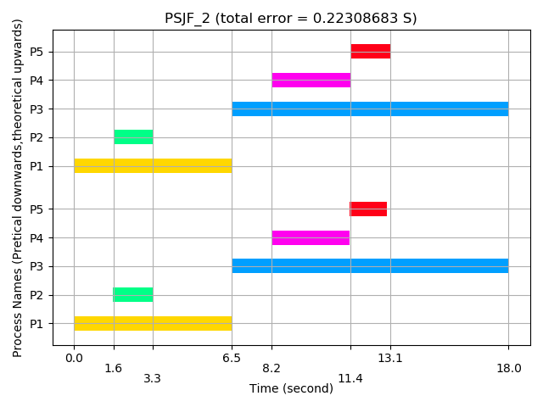

Test Data 3
PSJF 4 P1 0 2000 P2 500 500 P3 1000 500 P4 1500 500

Exclusion Result
[ 3945.321407] [Project1] 2612 1588168408.855796587 1588168409.635540611 [ 3946.072594] [Project1] 2613 1588168409.637421286 1588168410.386696315 [ 3946.893506] [Project1] 2614 1588168410.388225868 1588168411.207575397 [ 3949.356089] [Project1] 2611 1588168408.026120606 1588168413.670057886

Comparison of Theoretical and Pretical Results
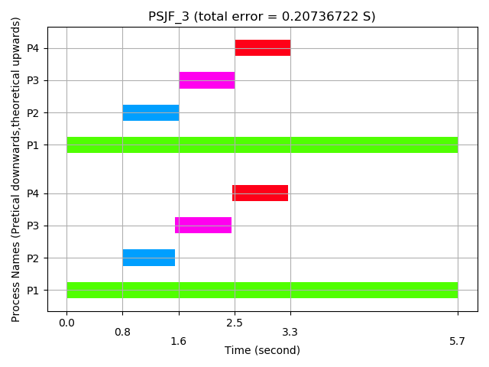

Test Data 4
PSJF 4 P1 0 7000 P2 0 2000 P3 100 1000 P4 200 4000

Exclusion Result
[ 3951.191765] [Project1] 2624 1588168413.839951428 1588168415.505659485 [ 3954.414490] [Project1] 2623 1588168413.680532190 1588168418.728253268 [ 3961.024168] [Project1] 2625 1588168418.728384321 1588168425.337662486 [ 3972.555337] [Project1] 2622 1588168425.337793976 1588168436.868362374

Comparison of Theoretical and Pretical Results
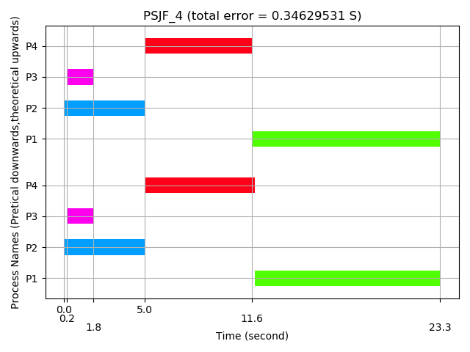

Test Data 5
PSJF 5 P1 100 100 P2 100 4000 P3 200 200 P4 200 4000 P5 200 7000

Exclusion Result
[ 3972.870730] [Project1] 2635 1588168437.014183349 1588168437.183743326 [ 3973.161501] [Project1] 2637 1588168437.185412355 1588168437.474502248 [ 3979.621266] [Project1] 2636 1588168437.474628456 1588168443.934003933 [ 3986.377239] [Project1] 2638 1588168443.934134972 1588168450.689702203 [ 3998.173417] [Project1] 2639 1588168450.689835431 1588168462.485400909

Comparison of Theoretical and Pretical Results
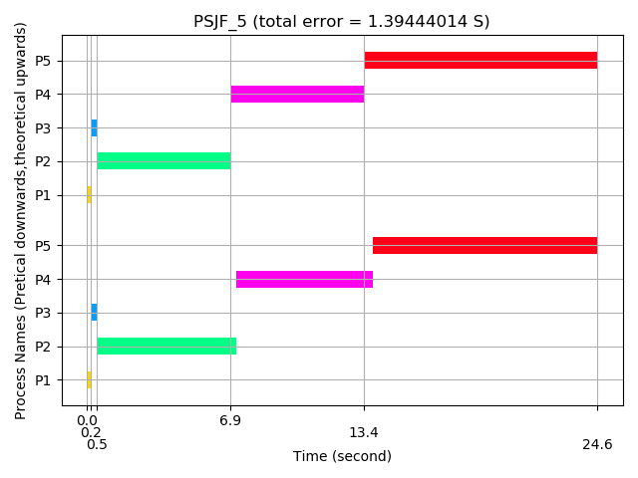

Conclusion
- 發現每一個process在run的時間都比理論值要長，即使是FIFO中第一個process的running time，也會比其需要的時間長。推測可能的原因是：
  - Project1的運行環境於virtual box中，virtual box 為原生系統的一個應用程式，其無法完全占用物理CPU
  - 與前一個原因相似，
  - 在兩次用timer計時之間的code,除了run process 還會做一些別的事情. void execute_unit_time(){ volatile unsigned long i; for(i=0;i<UNIT_TIME;i++); }
  - 在理論值中沒有考慮turn around的時間,而實際中在processes切換的時候需要短暫占用CPU.
  - Running Process的時候,只是一個for loop,不知道CPU和compiler會不會偷偷做一些黑魔法.

Reference:
- 测量Linux内核中函数的执行时间: https://www.codenong.com/4655711/
- 繪圖程式參考自:
https://github.com/wangyenjen/OS-Project-1/blob/master/report.md

